**QUESTION # 1**

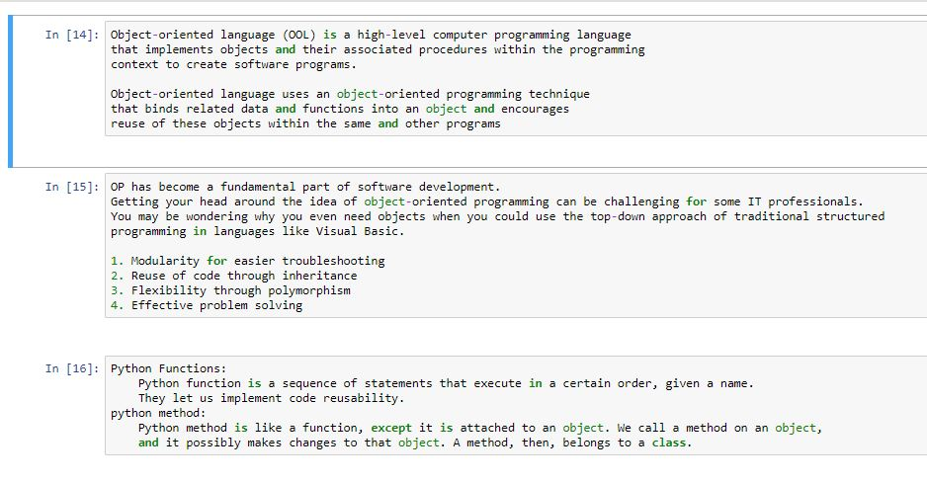

**QUESTION # 2**



**QUESTION # 3**

**QUESTION # 4**

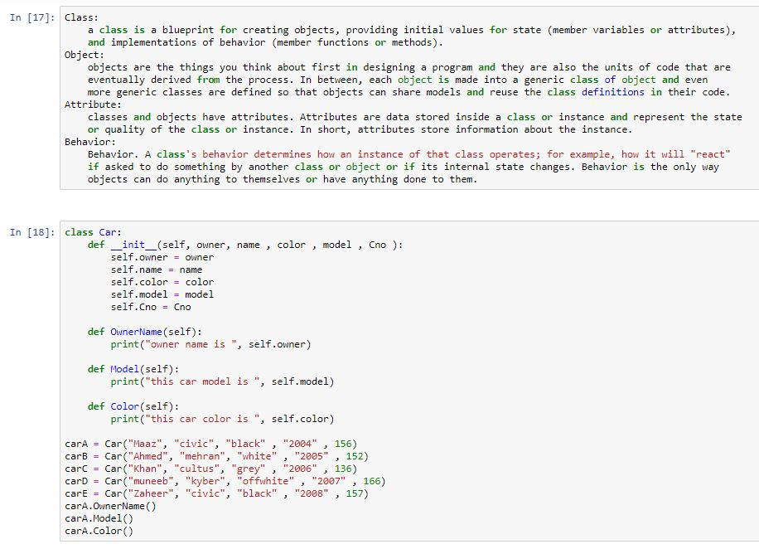

**QUESTION # 5**



